**Notification Demo**

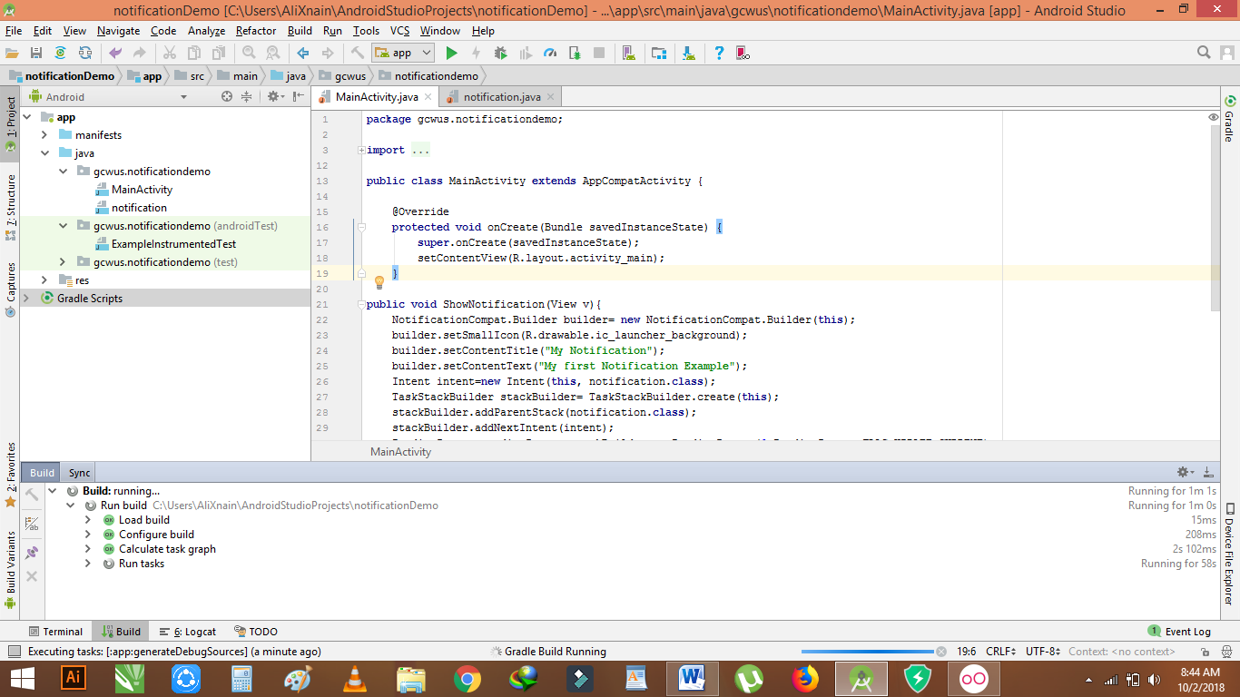

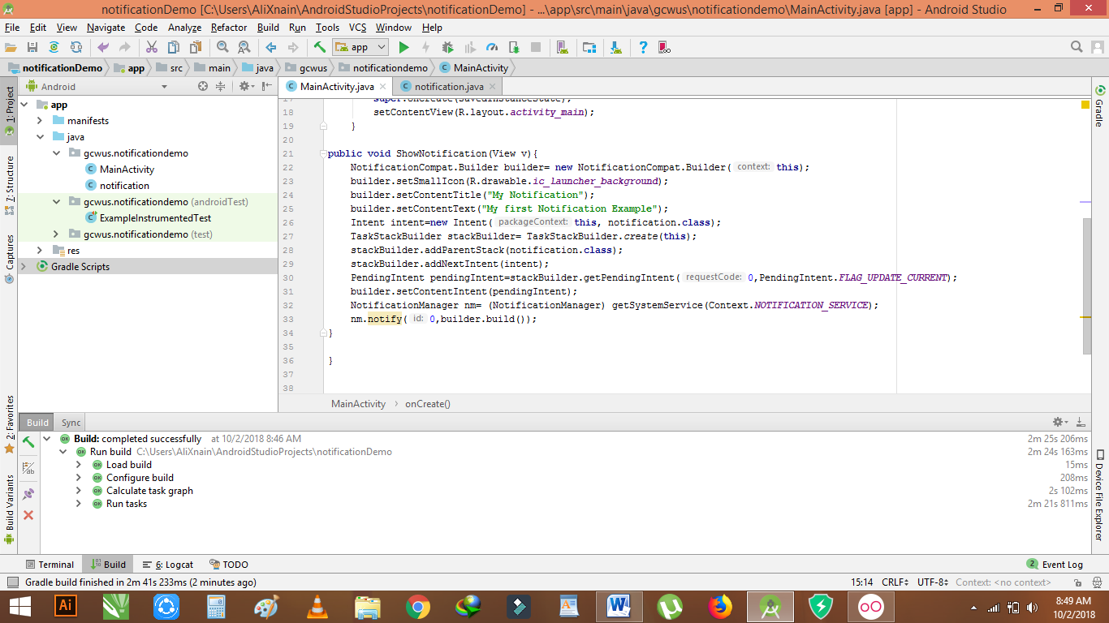

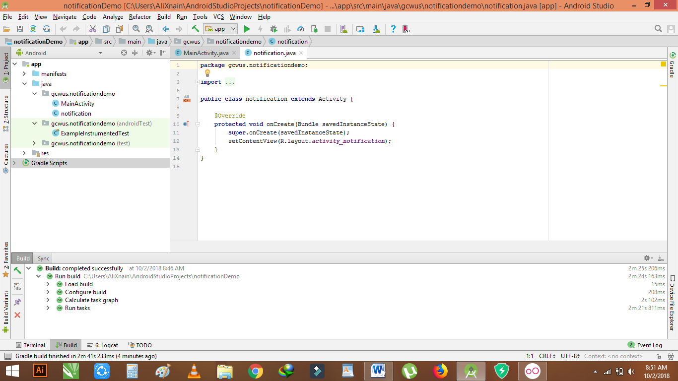

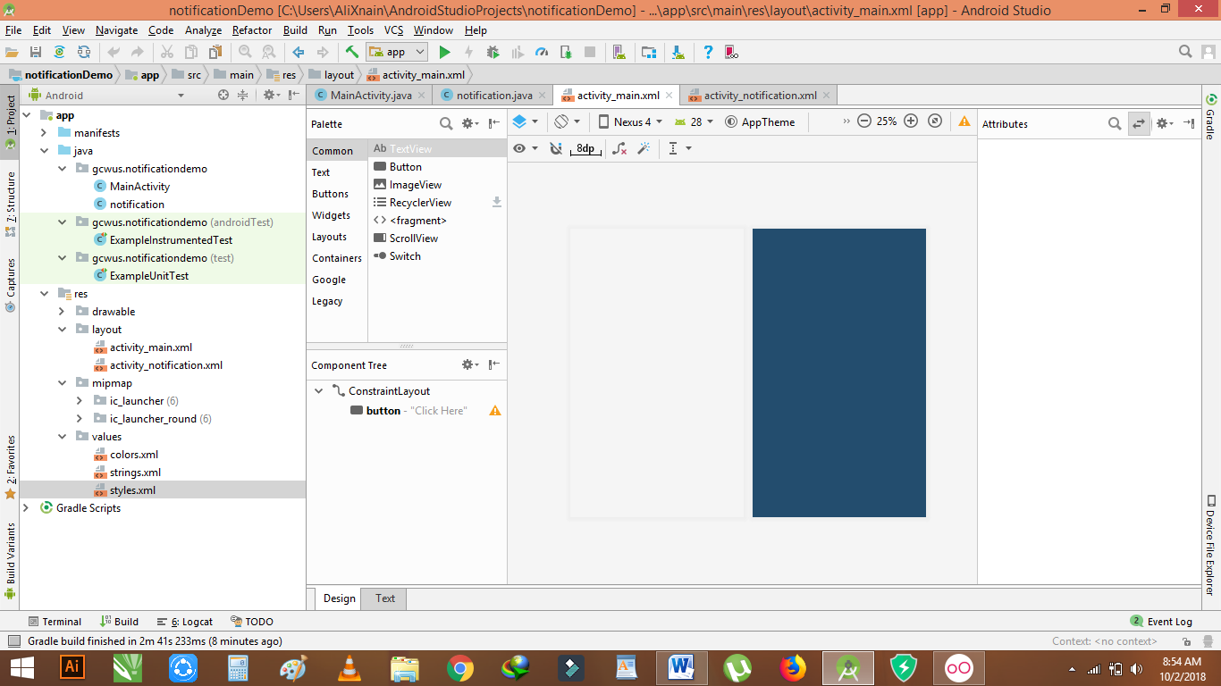

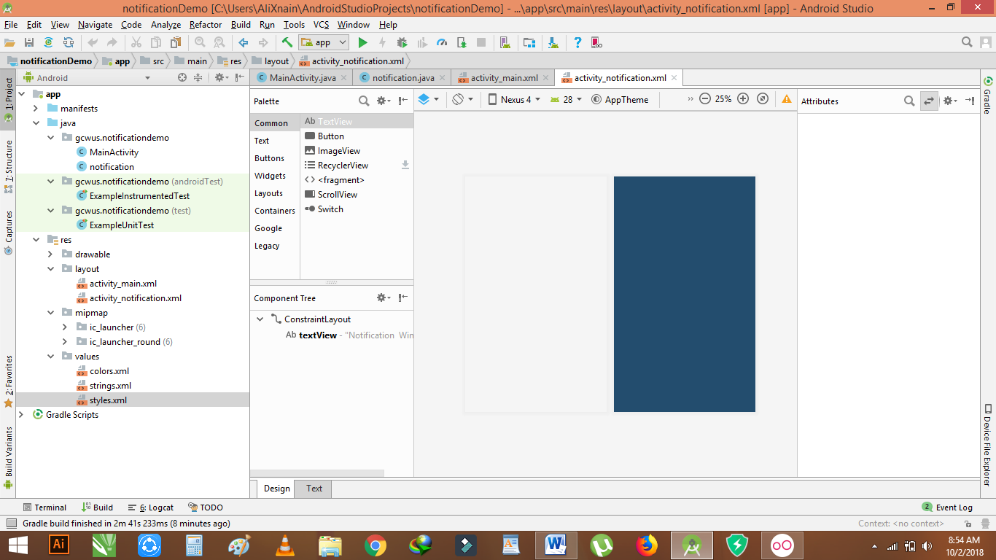

**Send msg from one activity to another**

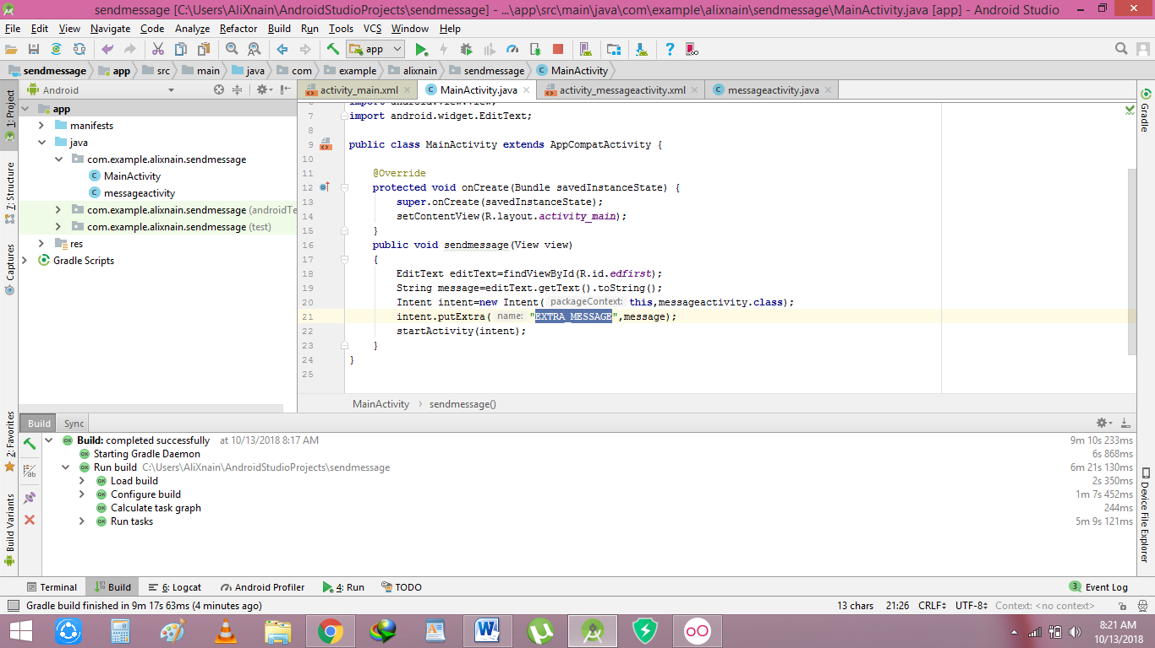

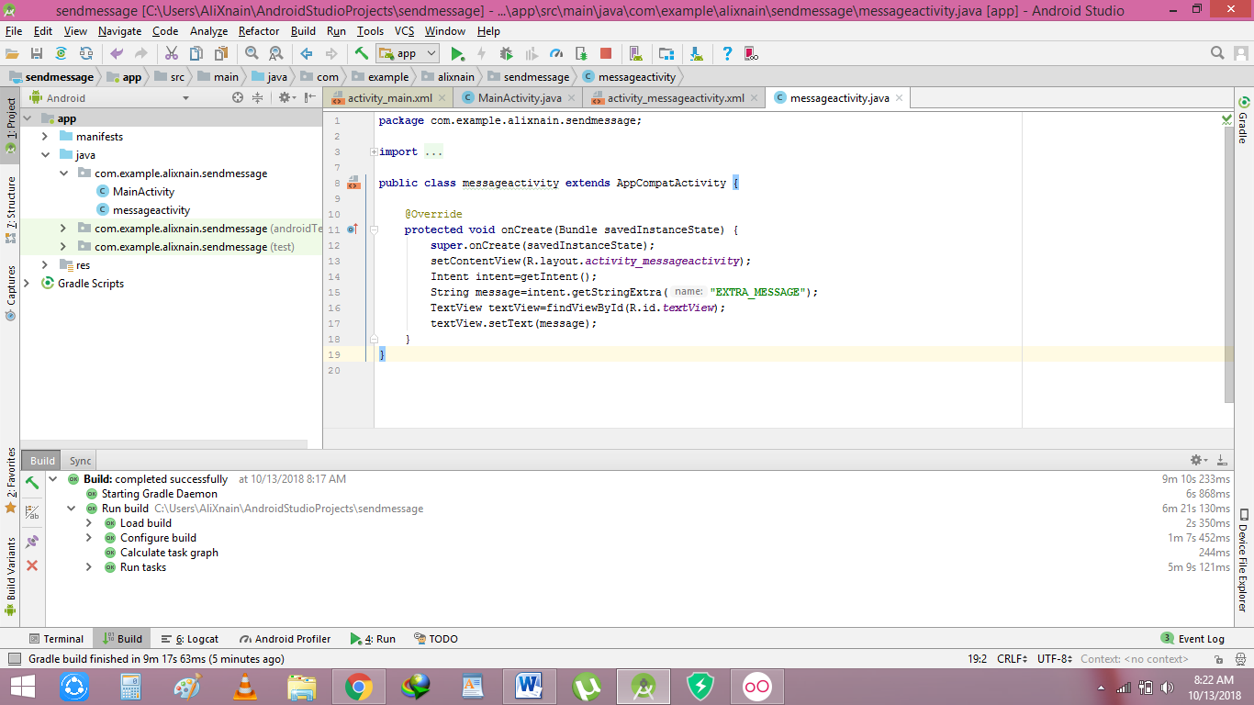

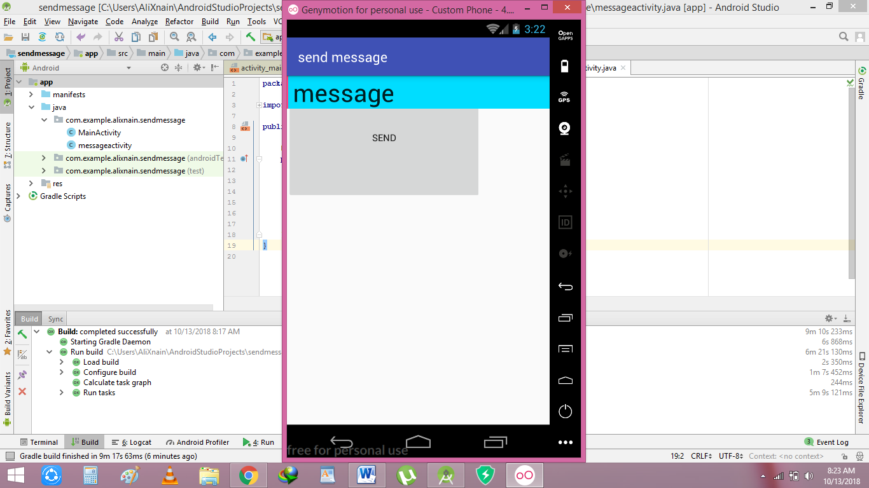

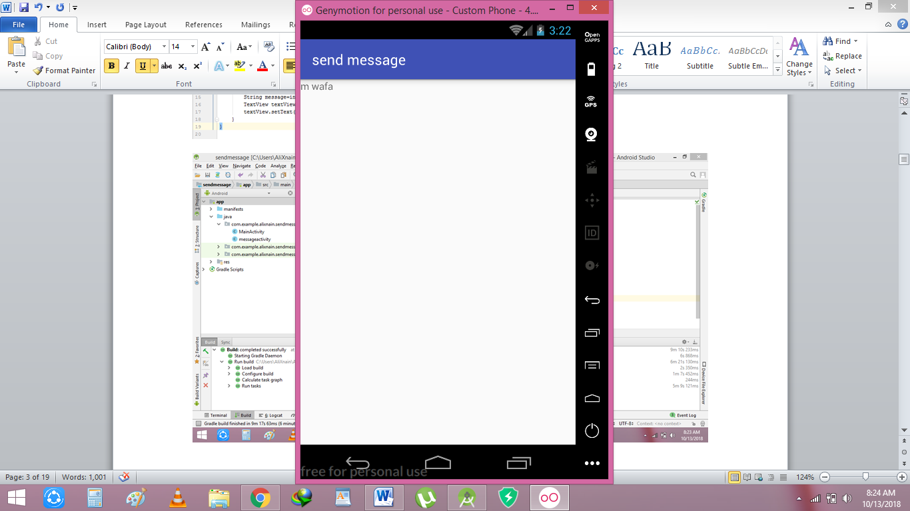

**Alert dialog**

**Notification Demo2**

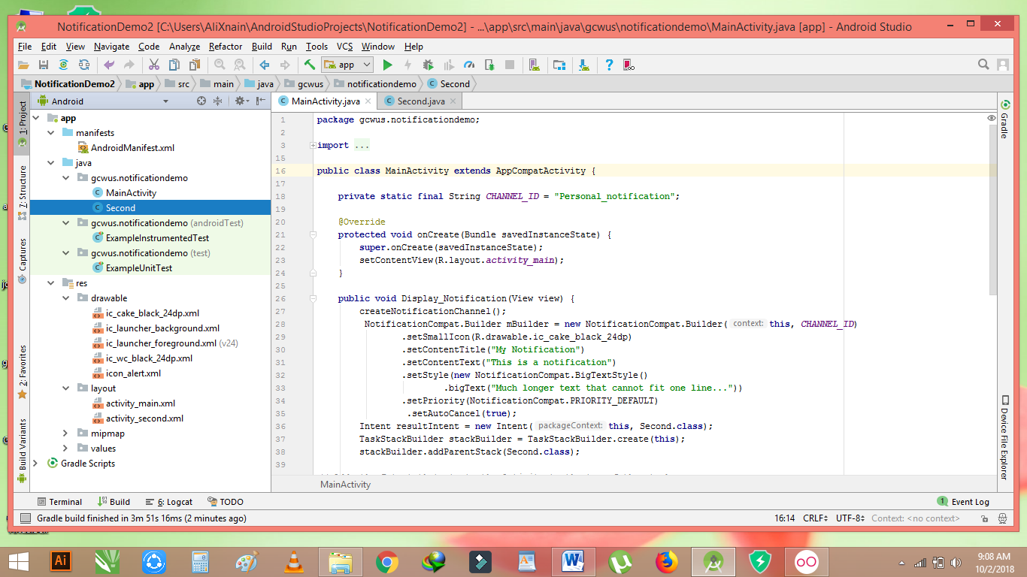

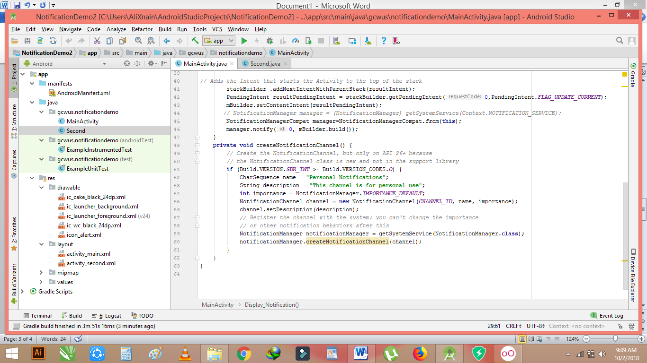

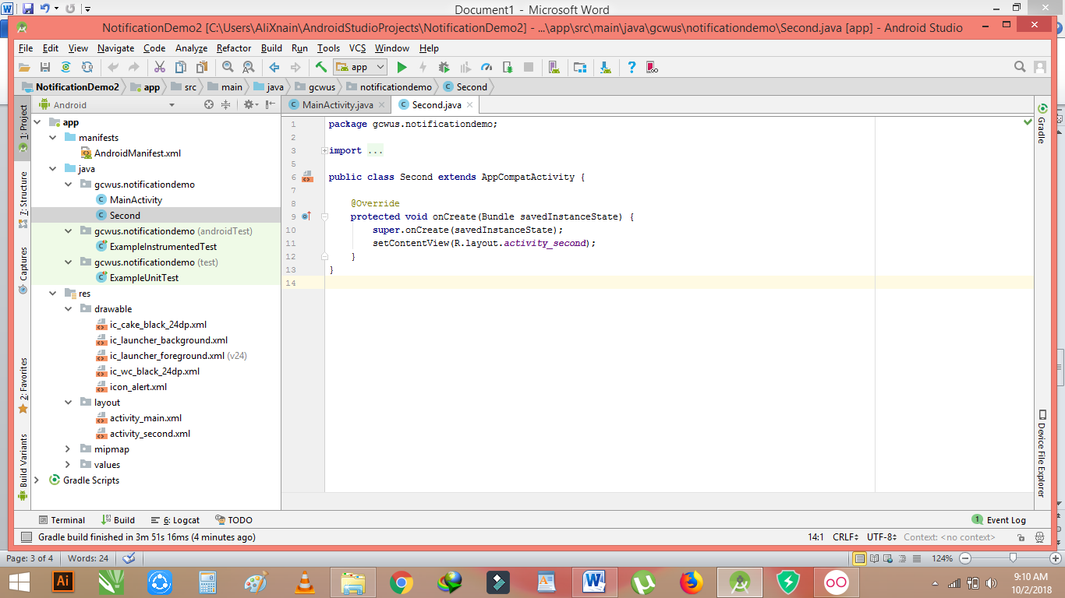

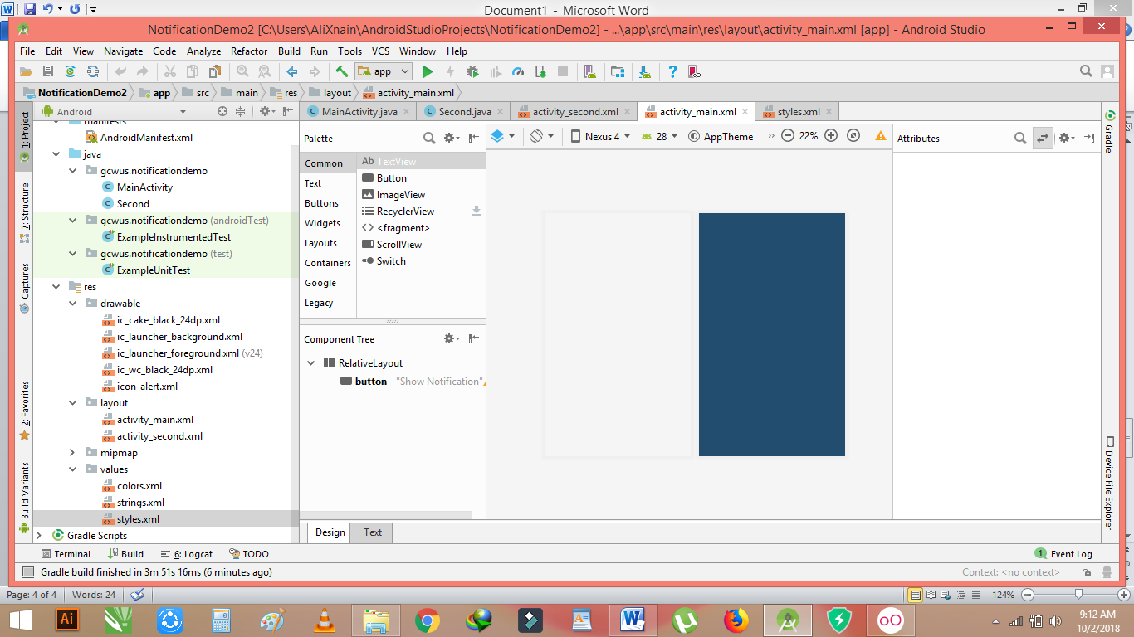

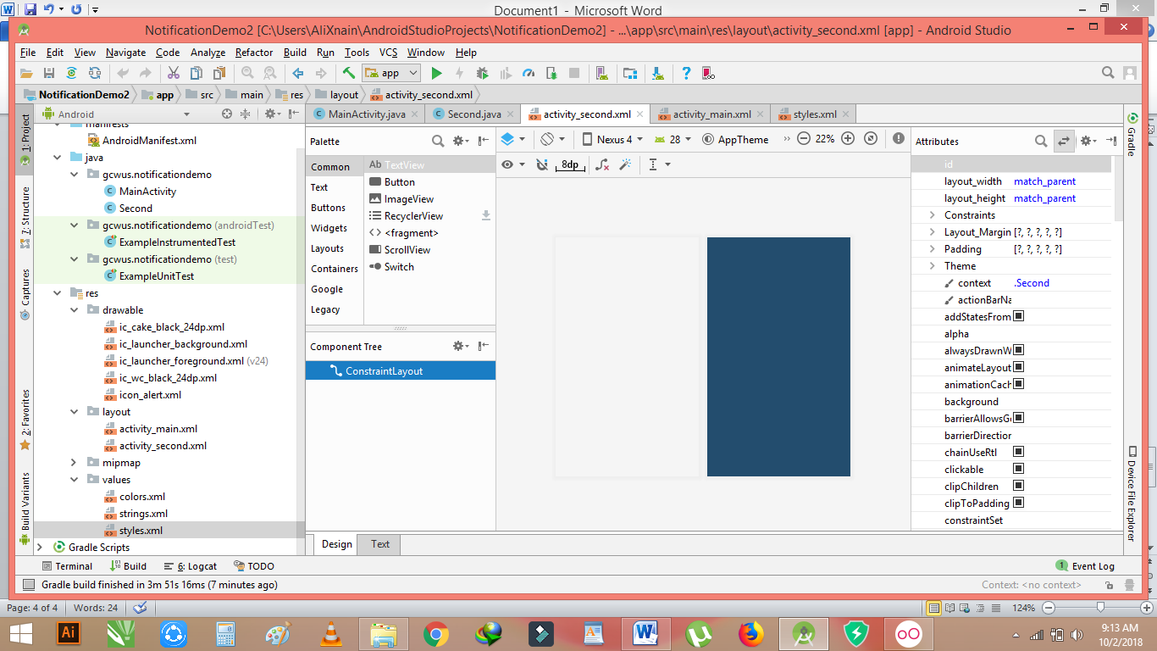

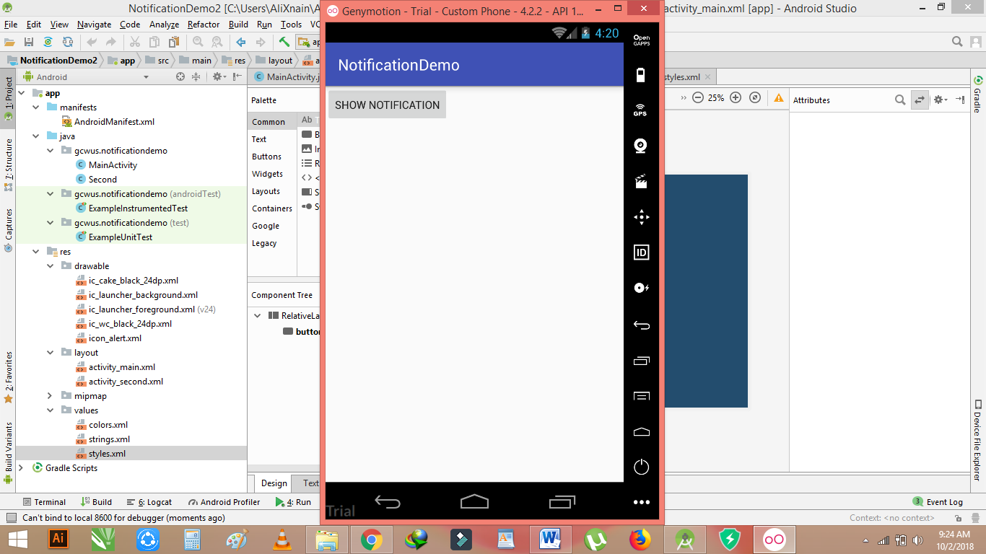

**Notification Demo22**

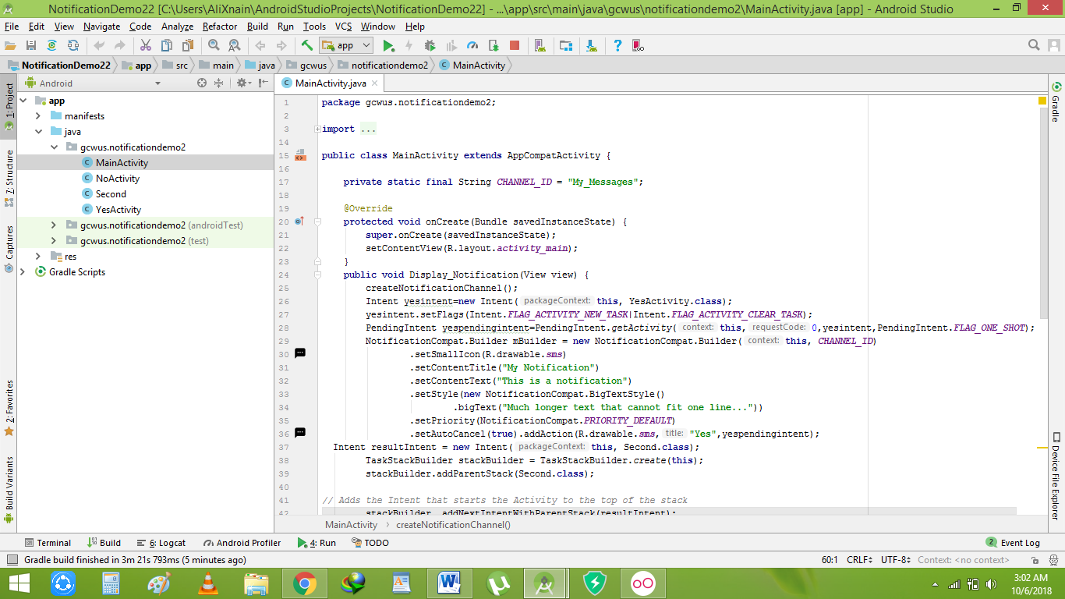

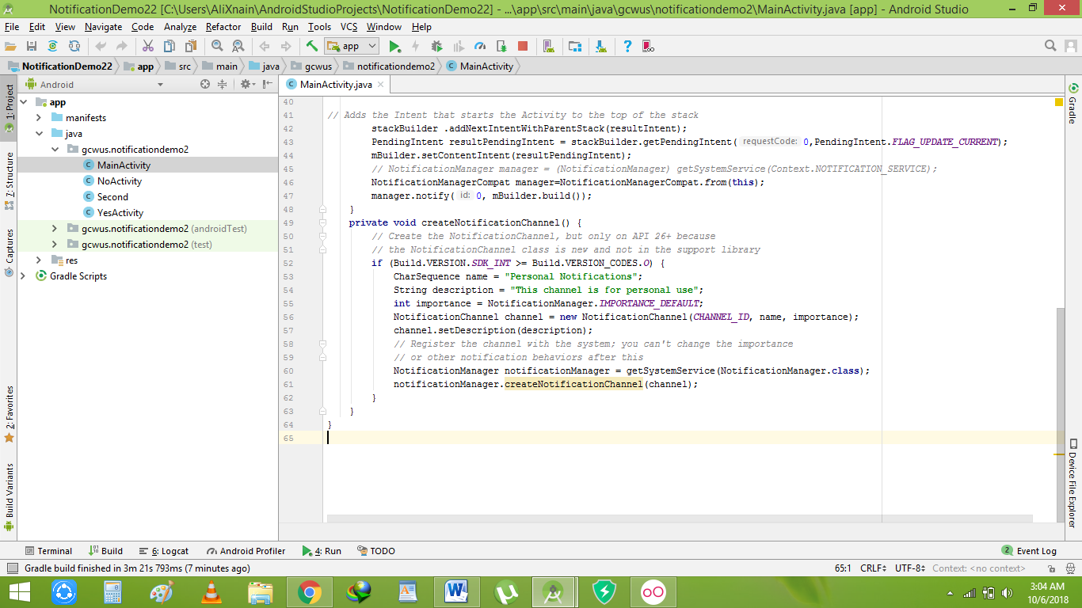

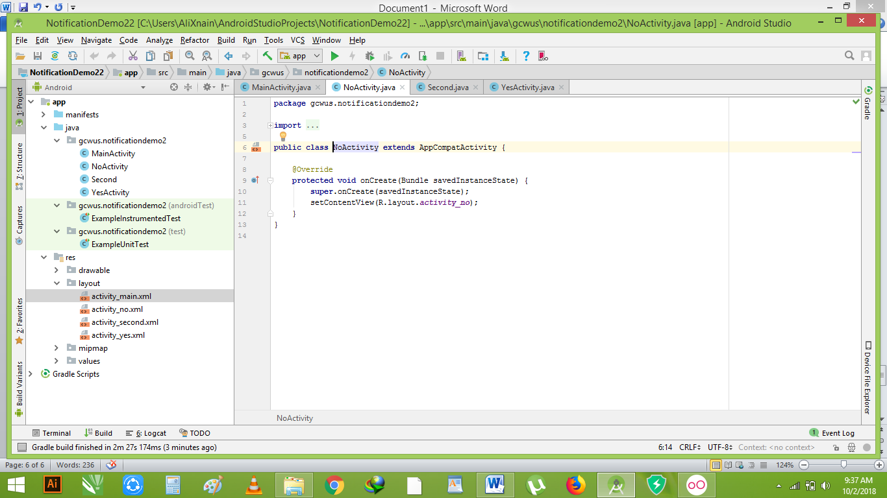

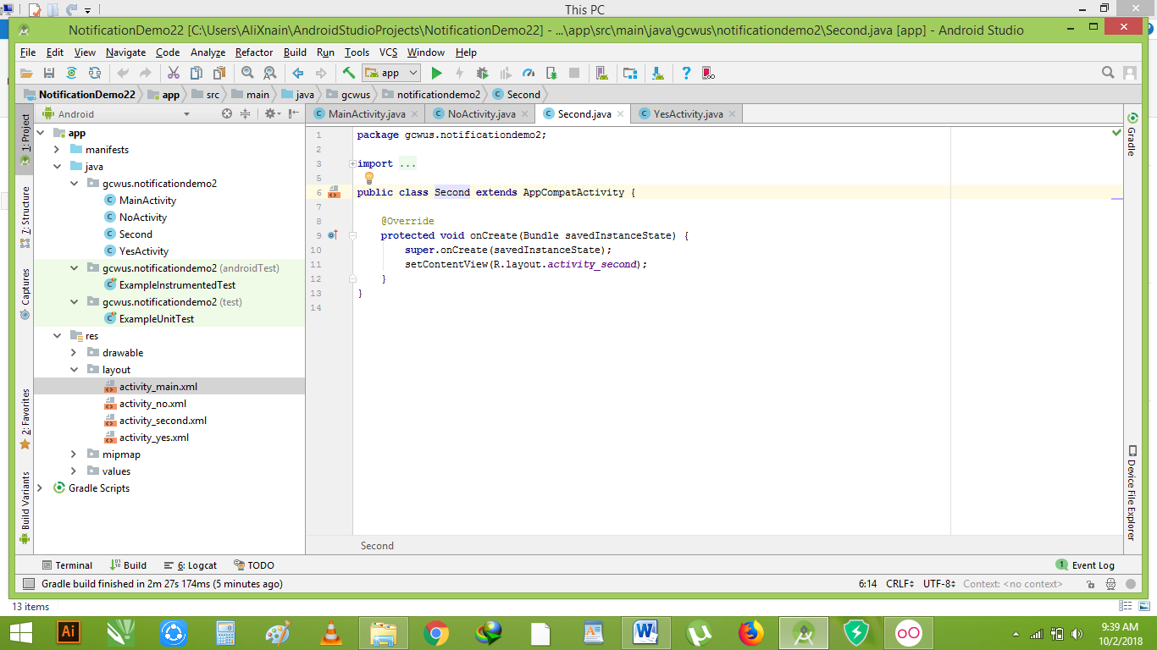

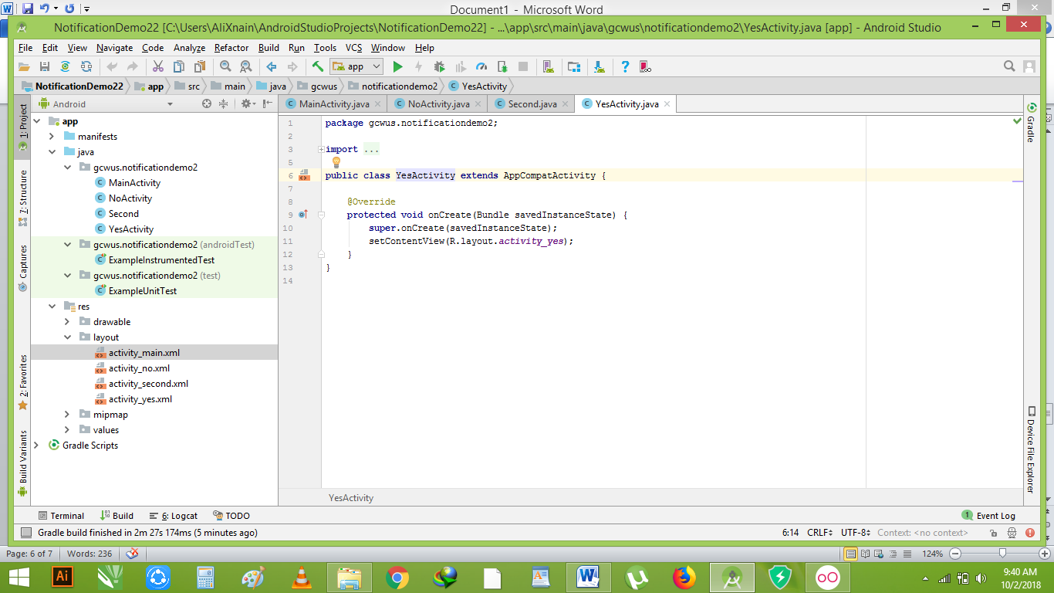

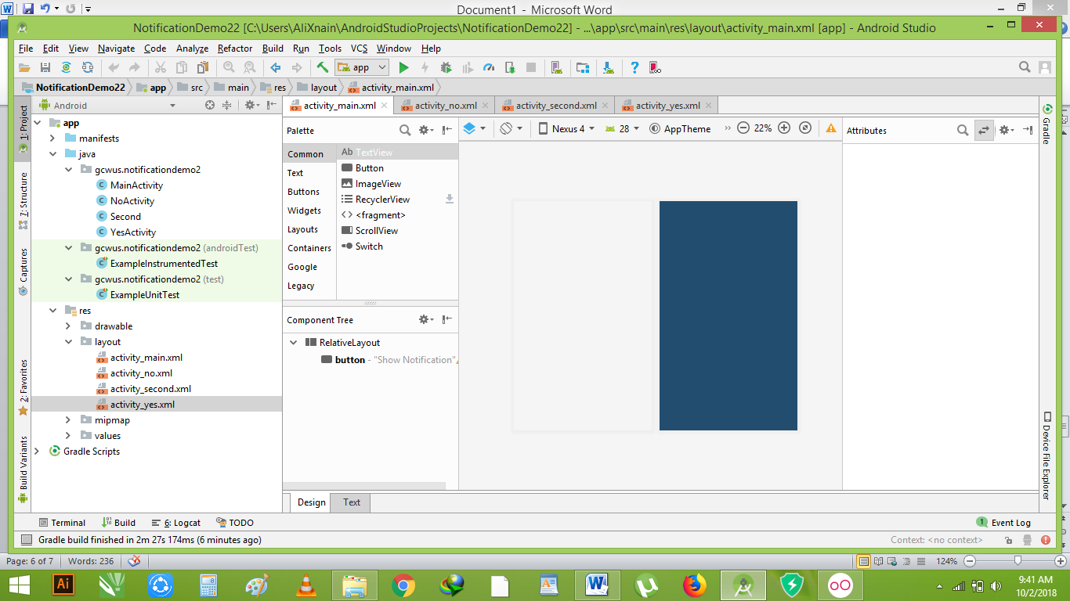

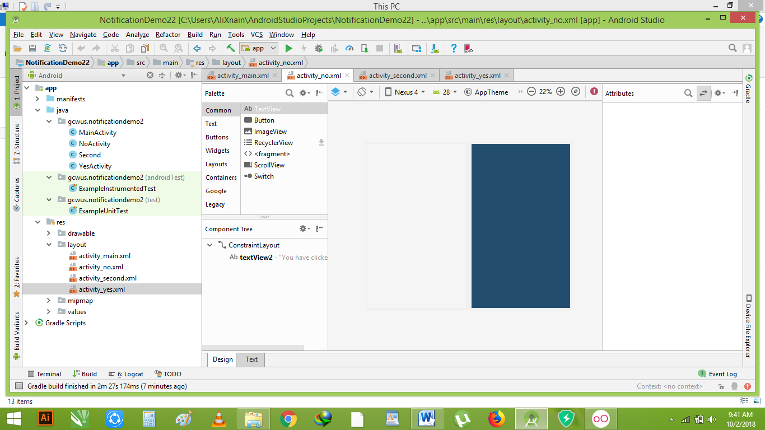

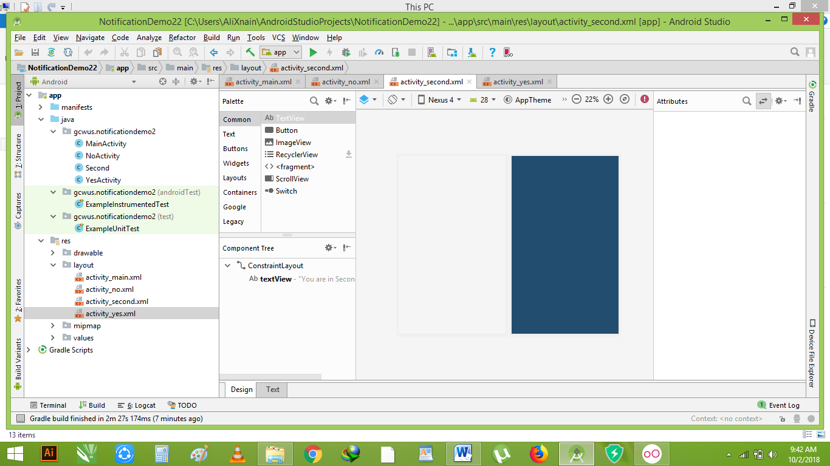

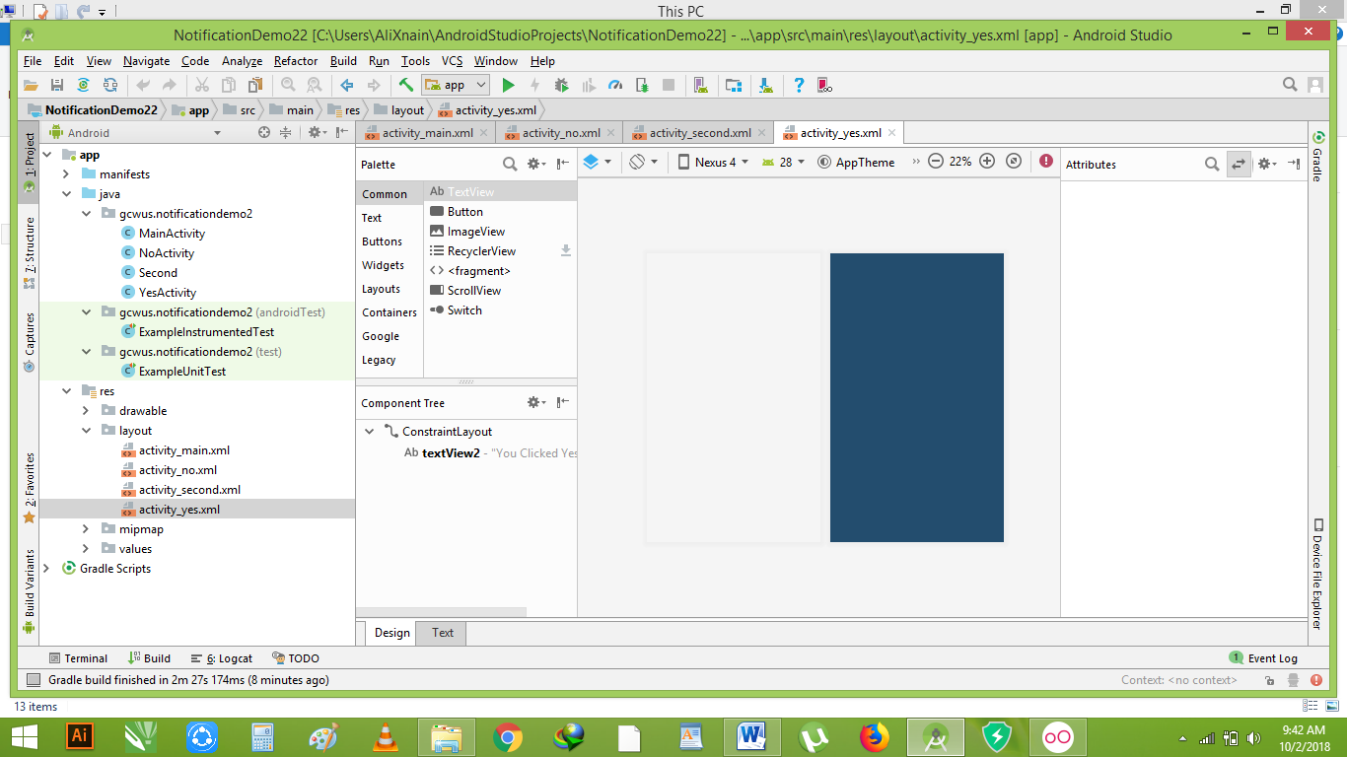

**Quick reply in notification:**

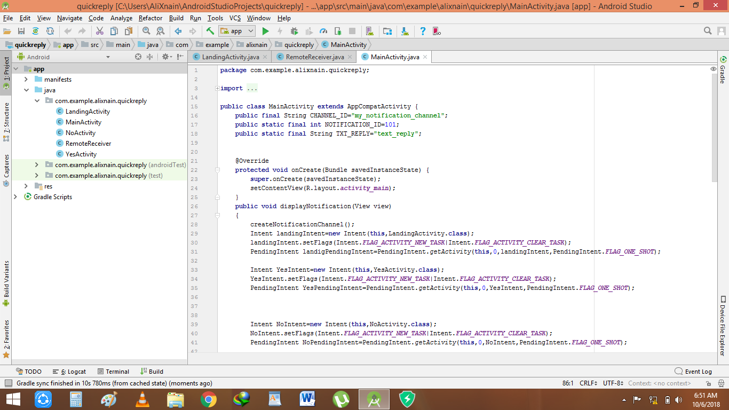

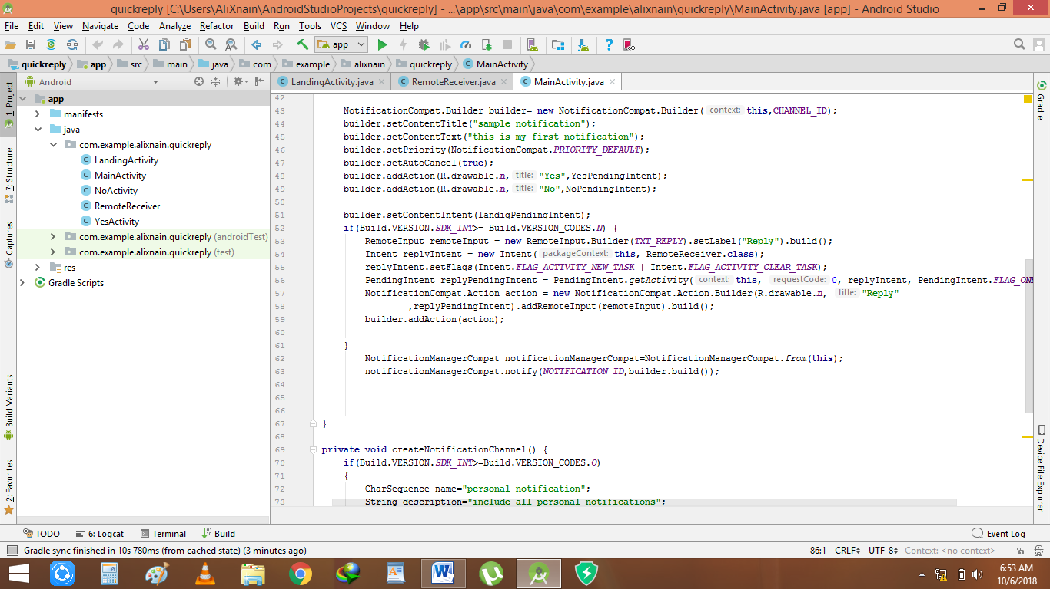

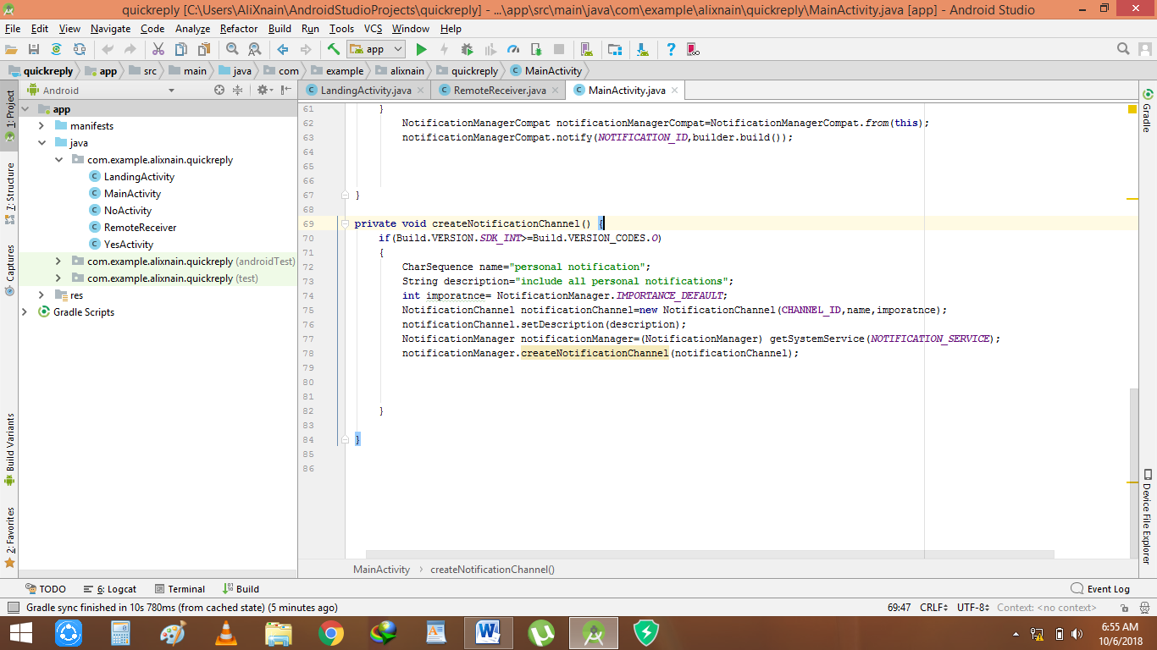

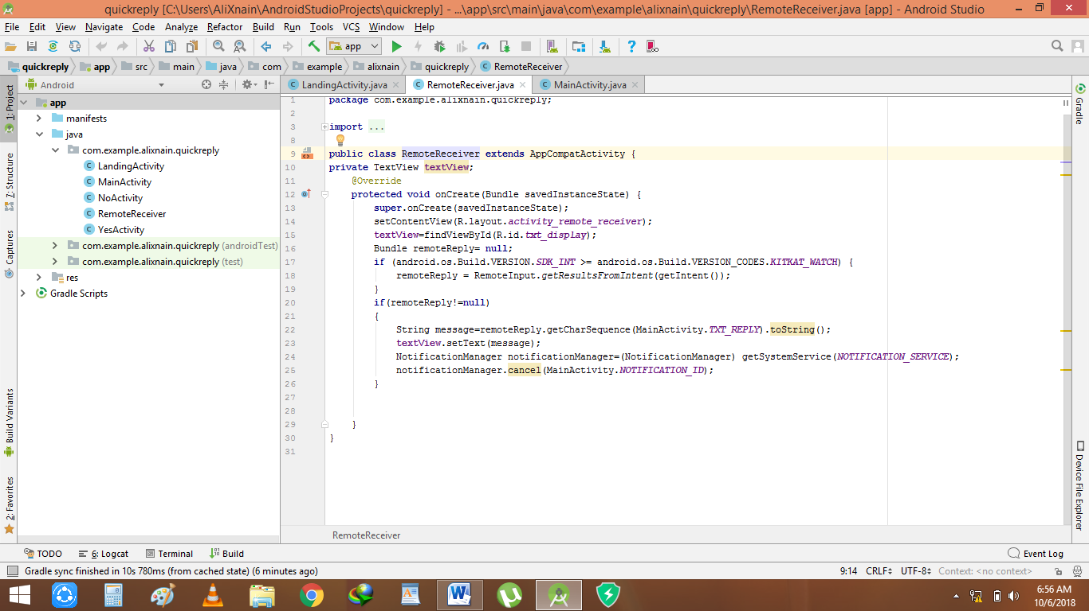

**Menu**

**Mainactiity.java**

**package** gcwus.menu;  
  
**import** android.content.Intent;  
**import** android.os.Bundle;  
**import** android.support.design.widget.FloatingActionButton;  
**import** android.support.design.widget.Snackbar;  
**import** android.support.v7.app.AppCompatActivity;  
**import** android.support.v7.widget.Toolbar;  
**import** android.view.View;  
**import** android.view.Menu;  
**import** android.view.MenuItem;  
  
**public class** MainActivity **extends** AppCompatActivity {  
  
 @Override  
 **protected void** onCreate(Bundle savedInstanceState) {  
 **super**.onCreate(savedInstanceState);  
 setContentView(R.layout.activity_main);  
 Toolbar toolbar = (Toolbar) findViewById(R.id.toolbar);  
 setSupportActionBar(toolbar);  
  
 FloatingActionButton fab = (FloatingActionButton) findViewById(R.id.fab);  
 fab.setOnClickListener(**new** View.OnClickListener() {  
 @Override  
 **public void** onClick(View view) {  
 Snackbar.make(view, **"Replace with your own action"**, Snackbar.LENGTH_LONG)  
 .setAction(**"Action"**, **null**).show();  
 }  
 });  
 }  
  
 @Override  
 **public boolean** onCreateOptionsMenu(Menu menu) {  
 *// Inflate the menu; this adds items to the action bar if it is present.* getMenuInflater().inflate(R.menu.menu_main, menu);  
 **return true**;  
 }  
  
 @Override  
 **public boolean** onOptionsItemSelected(MenuItem item) {  
  
 **switch**(item.getItemId()){  
  
 **case** R.id.Search:  
 Intent intent= **new** Intent(**this**, search.**class**);  
 startActivity(intent);  
 **break**;  
 **case** R.id.ContactUs:  
 Intent intent2= **new** Intent(**this**, contactus.**class**);  
 startActivity(intent2);  
 }  
  
  
 **return super**.onOptionsItemSelected(item);  
 }  
}

**search.java**

**package** gcwus.menu;  
  
**import** android.os.Bundle;  
**import** android.support.design.widget.FloatingActionButton;  
**import** android.support.design.widget.Snackbar;  
**import** android.support.v7.app.AppCompatActivity;  
**import** android.support.v7.widget.Toolbar;  
**import** android.view.View;  
  
**public class** search **extends** AppCompatActivity {  
  
 @Override  
 **protected void** onCreate(Bundle savedInstanceState) {  
 **super**.onCreate(savedInstanceState);  
 setContentView(R.layout.activity_search);  
 Toolbar toolbar = (Toolbar) findViewById(R.id.toolbar);  
 setSupportActionBar(toolbar);  
  
 FloatingActionButton fab = (FloatingActionButton) findViewById(R.id.fab);  
 fab.setOnClickListener(**new** View.OnClickListener() {  
 @Override  
 **public void** onClick(View view) {  
 Snackbar.make(view, **"Replace with your own action"**, Snackbar.LENGTH_LONG)  
 .setAction(**"Action"**, **null**).show();  
 }  
 });  
 }  
  
}

**contactus.java**

**package** gcwus.menu;  
  
**import** android.os.Bundle;  
**import** android.support.design.widget.FloatingActionButton;  
**import** android.support.design.widget.Snackbar;  
**import** android.support.v7.app.AppCompatActivity;  
**import** android.support.v7.widget.Toolbar;  
**import** android.view.View;  
  
**public class** contactus **extends** AppCompatActivity {  
  
 @Override  
 **protected void** onCreate(Bundle savedInstanceState) {  
 **super**.onCreate(savedInstanceState);  
 setContentView(R.layout.activity_contactus);  
 Toolbar toolbar = (Toolbar) findViewById(R.id.toolbar);  
 setSupportActionBar(toolbar);  
  
 FloatingActionButton fab = (FloatingActionButton) findViewById(R.id.fab);  
 fab.setOnClickListener(**new** View.OnClickListener() {  
 @Override  
 **public void** onClick(View view) {  
 Snackbar.make(view, **"Replace with your own action"**, Snackbar.LENGTH_LONG)  
 .setAction(**"Action"**, **null**).show();  
 }  
 });  
 }  
  
}

**Layout demo**

**package** gcwus.layoutdemo;  
  
**import** android.support.v7.app.AppCompatActivity;  
**import** android.os.Bundle;  
**import** android.view.Menu;  
**import** android.view.View;  
**import** android.widget.Button;  
**import** android.widget.ImageView;  
**import** android.widget.TextView;  
**import** android.widget.Toast;  
**import** android.app.Activity;  
  
**public class** MainActivity **extends** AppCompatActivity {  
  
 @Override  
 **protected void** onCreate(Bundle savedInstanceState) {  
 **super**.onCreate(savedInstanceState);  
 setContentView(R.layout.activity_main);  
 Button btn1=(Button)findViewById(R.id.btn1);  
 btn1.setOnClickListener(**new** Button.OnClickListener(){  
 **public void** onClick(View v) {  
  
 ImageView imageView=(ImageView) findViewById(R.id.imageView);  
 imageView.setImageResource(R.drawable.kjhhj);  
 *//TextView txt1 = (TextView) findViewById(R.id.txt1);  
 //txt1.setText("Hello");* }  
  
 }  
 );  
  
 *// Toast.makeText(getApplicationContext(),"Hello",Toast.LENGTH_SHORT).show();* }  
 */* public void btn(View v){  
  
 TextView txt1 = (TextView) findViewById(R.id.txt1);  
 txt1.setText("Hello");  
 }*/*}

**Linear layout**

**Mainactivity.java**

**package** gcwus.linearlayout;  
  
**import** android.content.Intent;  
**import** android.support.v7.app.AppCompatActivity;  
**import** android.os.Bundle;  
**import** android.view.View;  
**import** android.widget.Button;  
**import** android.widget.TextView;  
  
**public class** MainActivity **extends** AppCompatActivity {  
 **public static final int** msg_req = 01;  
  
 @Override  
 **protected void** onCreate(Bundle savedInstanceState) {  
  
 **super**.onCreate(savedInstanceState);  
 setContentView(R.layout.activity_main);  
  
  
  
 }  
  
  
 */* public void getMessage(View view) {  
 Intent intent = new Intent(this, messageActivity.class);  
 startActivityForResult(intent, msg_req);  
 }*/* @Override  
 **protected void** onActivityResult(**int** requestCode, **int** resultCode, Intent data) {  
 **super**.onActivityResult(requestCode, resultCode, data);  
 **if**(msg_req==requestCode)  
 {  
 **if**(resultCode==RESULT_OK) {  
 String message = data.getStringExtra(**"data"**);  
 TextView display=findViewById(R.id.textView);  
 display.setText(message);  
 }  
 }  
  
 }  
  
 **public void** send_message(View view) {  
 Intent intent=**new** Intent(**this**, messageActivity.**class**);  
 startActivityForResult(intent, msg_req);  
 }  
}

**Messageactivity.java**

**package** gcwus.linearlayout;  
  
**import** android.content.Intent;  
**import** android.support.v7.app.AppCompatActivity;  
**import** android.os.Bundle;  
**import** android.view.View;  
**import** android.widget.EditText;  
  
**public class** messageActivity **extends** AppCompatActivity {  
  
 @Override  
 **protected void** onCreate(Bundle savedInstanceState) {  
 **super**.onCreate(savedInstanceState);  
 setContentView(R.layout.***activity_message***);  
 }  
  
  
  
 **public void** send_msg(View view) {  
 EditText msg=findViewById(R.id.message);  
 String msgdata=msg.getText().toString();  
 Intent msgIntent=**new** Intent();  
 msgIntent.putExtra(**"data"**,msgdata);  
 setResult(RESULT_OK, msgIntent);  
 finish();  
 }  
  
}

**Intent demo**

**.java**

**package** gcwus.intentdemo;  
  
**import** android.support.v7.app.AppCompatActivity;  
**import** android.os.Bundle;  
**import** android.app.Activity;  
**import** android.view.Menu;  
**import** android.view.View;  
**import** android.view.View.OnClickListener;  
**import** android.widget.Button;  
**import** android.widget.EditText;  
**import** android.widget.Toast;  
  
**public class** MainActivity **extends** AppCompatActivity {  
  
 @Override  
 **protected void** onCreate(Bundle savedInstanceState) {  
 **super**.onCreate(savedInstanceState);  
 setContentView(R.layout.activity_main);  
  
  
  
 Button buttonSum=(Button)findViewById(R.id.add);  
  
 buttonSum.setOnClickListener(**new** View.OnClickListener(){  
  
 @Override  
 **public void** onClick(View view) {  
 EditText editText1=(EditText)findViewById(R.id.editText1);  
 EditText editText2=(EditText)findViewById(R.id.editText2);  
 String value1=editText1.getText().toString();  
 String value2=editText2.getText().toString();  
 **int** a=Integer.parseInt(value1);  
 **int** b=Integer.parseInt(value2);  
 **int** sum=a+b;  
 Toast.makeText(getApplicationContext(),String.valueOf(sum),Toast.LENGTH_LONG).show();  
 }  
  
 }); }  
  
  
  
}

**Intents**

**Mainactivity.java**

**package** gcwus.intents;  
  
**import** android.content.Intent;  
**import** android.support.v7.app.AppCompatActivity;  
**import** android.os.Bundle;  
**import** android.view.View;  
**import** android.widget.Button;  
**import** android.widget.EditText;  
  
**public class** MainActivity **extends** AppCompatActivity {  
  
 @Override  
 **protected void** onCreate(Bundle savedInstanceState) {  
 **super**.onCreate(savedInstanceState);  
 setContentView(R.layout.***activity_main***);  
 Button login = findViewById(R.id.***button***);  
  
 login.setOnClickListener(**new** Button.OnClickListener() {  
  
  
 @Override  
 **public void** onClick(View view) {  
  
 *// 1. create an intent pass class name or intnet action name* EditText name=findViewById(R.id.***editText***);  
 String msg= name.getText().toString();  
 Intent intent = **new** Intent(MainActivity.**this**, Activity2.**class**);  
  
 *// 2. put key/value data* intent.putExtra(**"message"**, msg);  
  
 *// 3. or you can add data to a bundle  
  
 // 5. start the activity* startActivity(intent);  
 }  
 });  
  
 }  
}

**activity2.java**

**package** gcwus.intents;  
  
**import** android.content.Intent;  
**import** android.support.v7.app.AppCompatActivity;  
**import** android.os.Bundle;  
**import** android.view.View;  
**import** android.widget.Button;  
**import** android.widget.TextView;  
**import** android.widget.Toast;  
  
**public class** Activity2 **extends** AppCompatActivity {  
  
 @Override  
 **protected void** onCreate(Bundle savedInstanceState) {  
 **super**.onCreate(savedInstanceState);  
 setContentView(R.layout.***activity_2***);  
 Intent intent = getIntent();  
  
 *// 2. get message value from intent* String message = intent.getStringExtra(**"message"**);  
  
 *// 3. show message on textView* ((TextView)findViewById(R.id.***textView***)).setText(message);  
 Button btn=findViewById(R.id.***button2***);  
 Button next=findViewById(R.id.***next***);  
 btn.setOnClickListener(**new** View.OnClickListener() {  
 @Override  
 **public void** onClick(View view) {  
 Intent Back = **new** Intent(Activity2.**this**, MainActivity.**class** );  
 startActivity(Back);  
 }  
 });  
 next.setOnClickListener(**new** View.OnClickListener() {  
 @Override  
 **public void** onClick(View view) {  
 Intent Back = **new** Intent(Activity2.**this**, activity3.**class** );  
 startActivity(Back);  
 }  
 });  
  
 }  
}

**activity3.java**

**package** gcwus.intents;  
  
**import** android.content.Intent;  
**import** android.support.v7.app.AppCompatActivity;  
**import** android.os.Bundle;  
**import** android.view.View;  
**import** android.widget.Button;  
  
**public class** activity3 **extends** AppCompatActivity {  
  
 @Override  
 **protected void** onCreate(Bundle savedInstanceState) {  
 **super**.onCreate(savedInstanceState);  
 setContentView(R.layout.***activity_activity3***);  
 Button btn=findViewById(R.id.***button3***);  
 btn.setOnClickListener(**new** View.OnClickListener() {  
 @Override  
 **public void** onClick(View view) {  
 Intent Back = **new** Intent(activity3.**this**, Activity2.**class** );  
 startActivity(Back);  
 }  
 });  
 Button home=findViewById(R.id.***button4***);  
 home.setOnClickListener(**new** View.OnClickListener() {  
 @Override  
 **public void** onClick(View view) {  
 Intent Back = **new** Intent(activity3.**this**, MainActivity.**class** );  
 startActivity(Back);  
 }  
 });  
 }  
}

**activity4.java**

**package** gcwus.intents;  
  
**import** android.support.v7.app.AppCompatActivity;  
**import** android.os.Bundle;  
  
**public class** activity4 **extends** AppCompatActivity {  
  
 @Override  
 **protected void** onCreate(Bundle savedInstanceState) {  
 **super**.onCreate(savedInstanceState);  
 setContentView(R.layout.***activity_activity4***);  
 }  
}

**Image UI**

**package** gcwus.imgui;  
  
**import** android.support.v7.app.AppCompatActivity;  
**import** android.os.Bundle;  
**import** android.view.View;  
**import** android.widget.ImageButton;  
**import** android.widget.Toast;  
  
**public class** MainActivity **extends** AppCompatActivity {  
  
 @Override  
 **protected void** onCreate(Bundle savedInstanceState) {  
 **super**.onCreate(savedInstanceState);  
 setContentView(R.layout.***activity_main***);  
 ImageButton imgbtn= findViewById(R.id.***imageButton***);  
 imgbtn.setOnClickListener(**new** View.OnClickListener() {  
 @Override  
 **public void** onClick(View v) {  
 Toast.*makeText*(MainActivity.**this**, **"You clicked an image button"**, Toast.***LENGTH_SHORT***).show();  
 }  
 });  
 }  
}

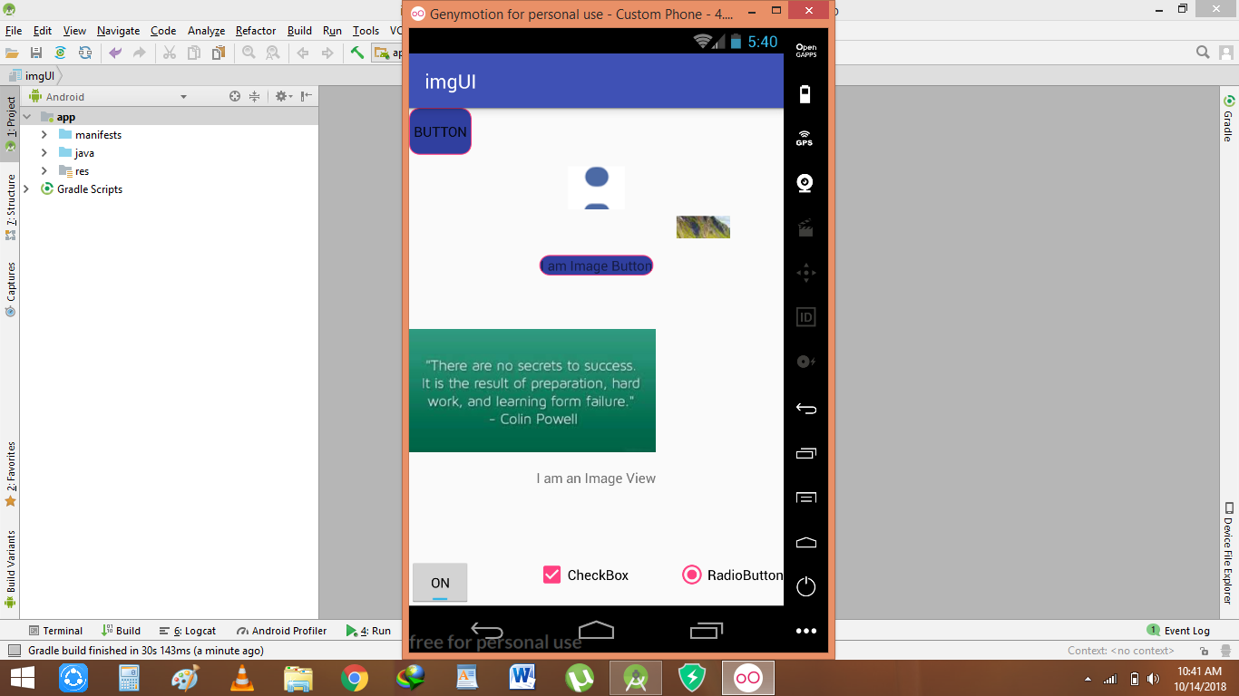

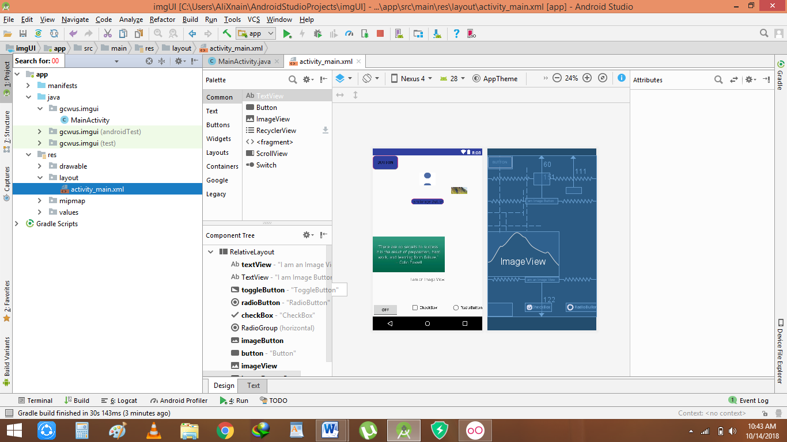

**Calculator**

**package** com.example.alixnain.calculator;  
  
**import** android.support.v7.app.AppCompatActivity;  
**import** android.os.Bundle;  
**import** android.view.View;  
**import** android.widget.Button;  
**import** android.widget.EditText;  
**import** android.widget.TextView;  
  
**public class** MainActivity **extends** AppCompatActivity {  
EditText **editfirst**,**editsecond**;  
Button **btnadd**,**btnsub**,**btnmul**,**btndiv**;  
TextView **tresult**;  
 @Override  
 **protected void** onCreate(Bundle savedInstanceState) {  
 **super**.onCreate(savedInstanceState);  
 setContentView(R.layout.activity_main);  
 **editfirst**=(EditText)findViewById(R.id.editfirst);  
 **editsecond**=(EditText)findViewById(R.id.editsecond);  
 **btnadd**=(Button) findViewById(R.id.btnadd);  
 **btnsub**=(Button) findViewById(R.id.btnsub);  
 **btnmul**=(Button) findViewById(R.id.btnmul);  
 **btndiv**=(Button) findViewById(R.id.btndiv);  
 **tresult**=(TextView) findViewById(R.id.tresult);  
 **btnadd**.setOnClickListener(**new** View.OnClickListener() {  
 @Override  
 **public void** onClick(View v) {  
 **double** first,second,result;  
 first=Double.*valueOf*(**editfirst**.getText().toString());  
 second=Double.*valueOf*(**editsecond**.getText().toString());  
 result=first+second;  
 **tresult**.setText(**"Result is:"**+result);  
 }  
 });  
 **btnsub**.setOnClickListener(**new** View.OnClickListener() {  
 @Override  
 **public void** onClick(View v) {  
 **double** first,second,result;  
 first=Double.*valueOf*(**editfirst**.getText().toString());  
 second=Double.*valueOf*(**editsecond**.getText().toString());  
 result=first-second;  
 **tresult**.setText(**"Result is:"**+result);  
 }  
 });  
 **btnmul**.setOnClickListener(**new** View.OnClickListener() {  
 @Override  
 **public void** onClick(View v) {  
 **double** first,second,result;  
 first=Double.*valueOf*(**editfirst**.getText().toString());  
 second=Double.*valueOf*(**editsecond**.getText().toString());  
 result=first*second;  
 **tresult**.setText(**"Result is:"**+result);  
 }  
 });  
 **btndiv**.setOnClickListener(**new** View.OnClickListener() {  
 @Override  
 **public void** onClick(View v) {  
 **double** first,second,result;  
 first=Double.*valueOf*(**editfirst**.getText().toString());  
 second=Double.*valueOf*(**editsecond**.getText().toString());  
 result=first/second;  
 **tresult**.setText(**"Result is:"**+result);  
 }  
 });  
 }  
}

**ALL alerts dialog**

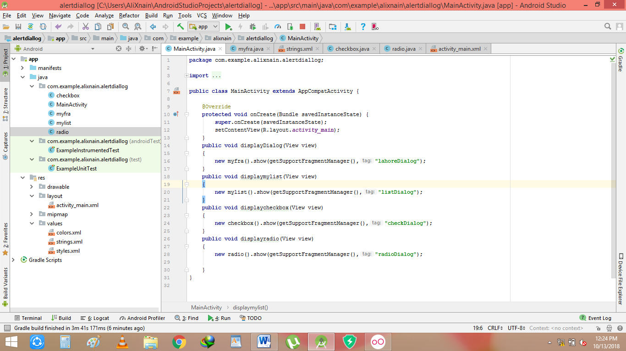

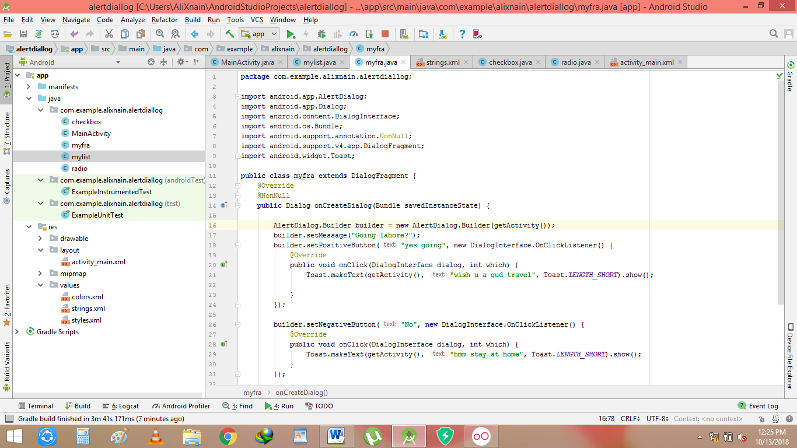

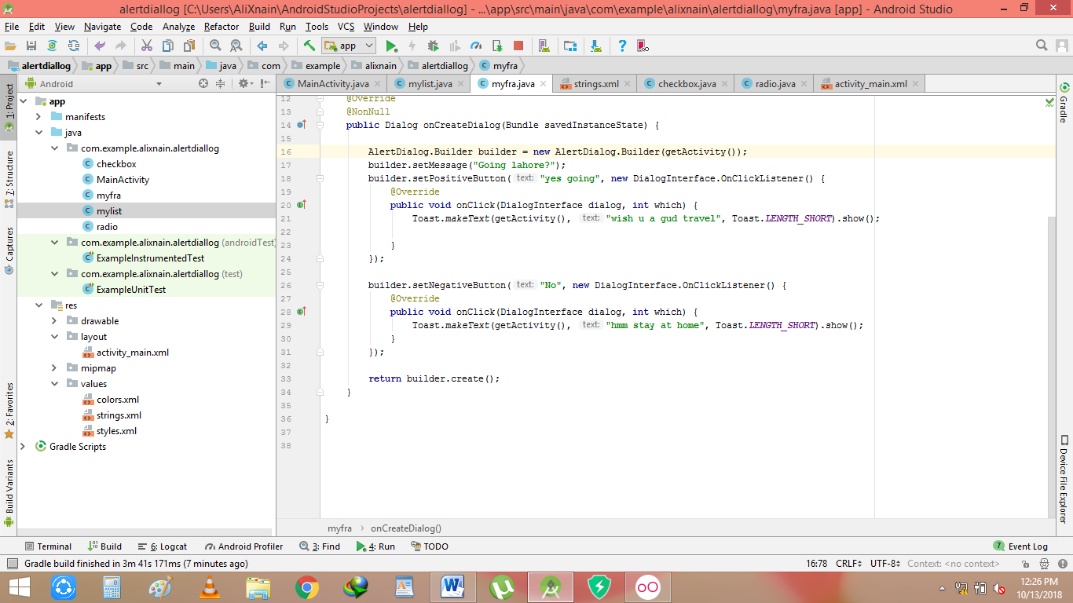

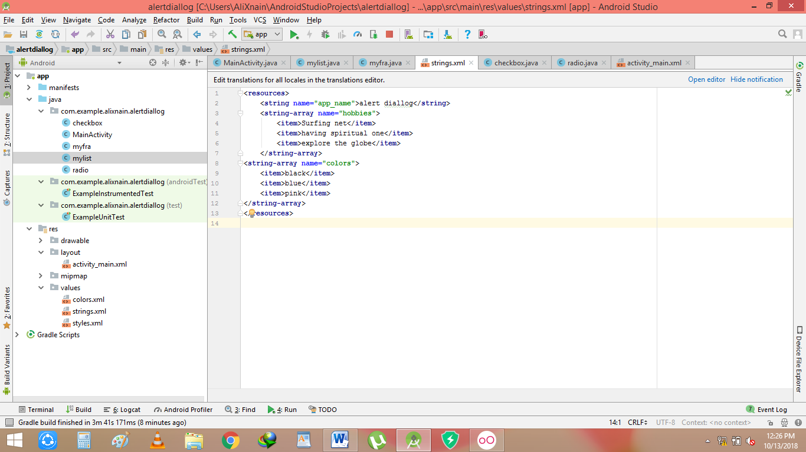

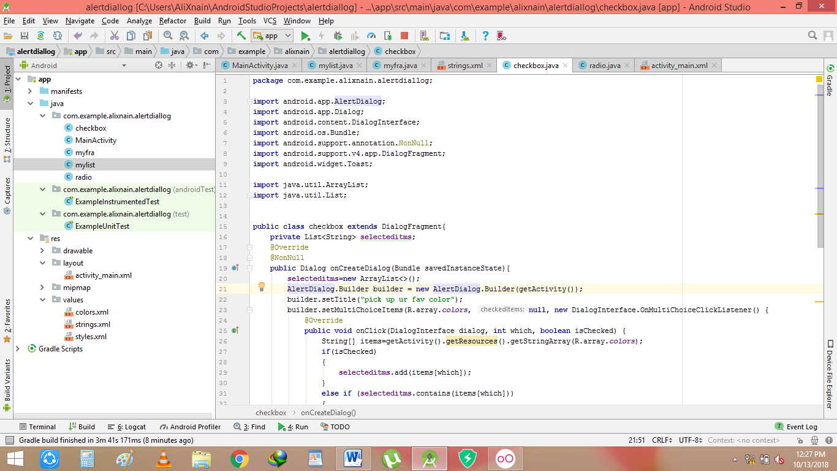

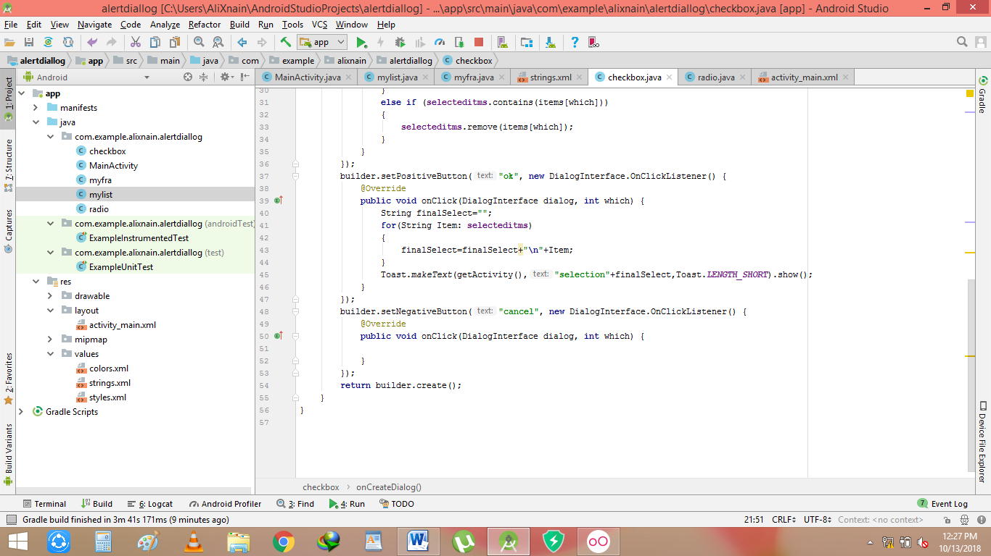

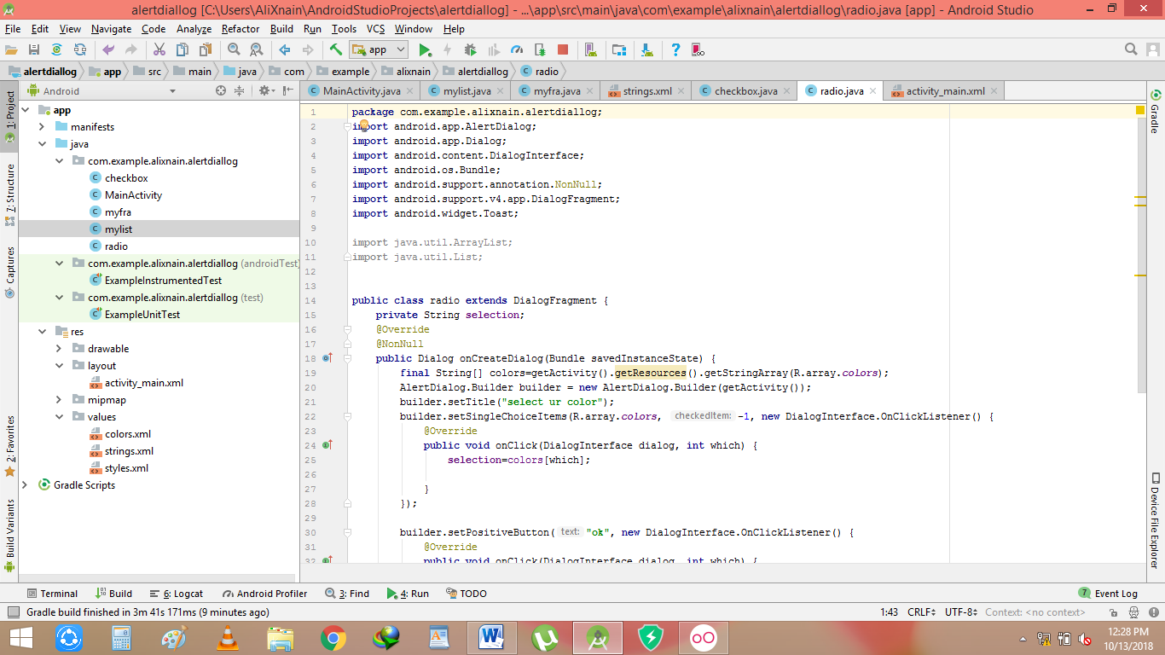

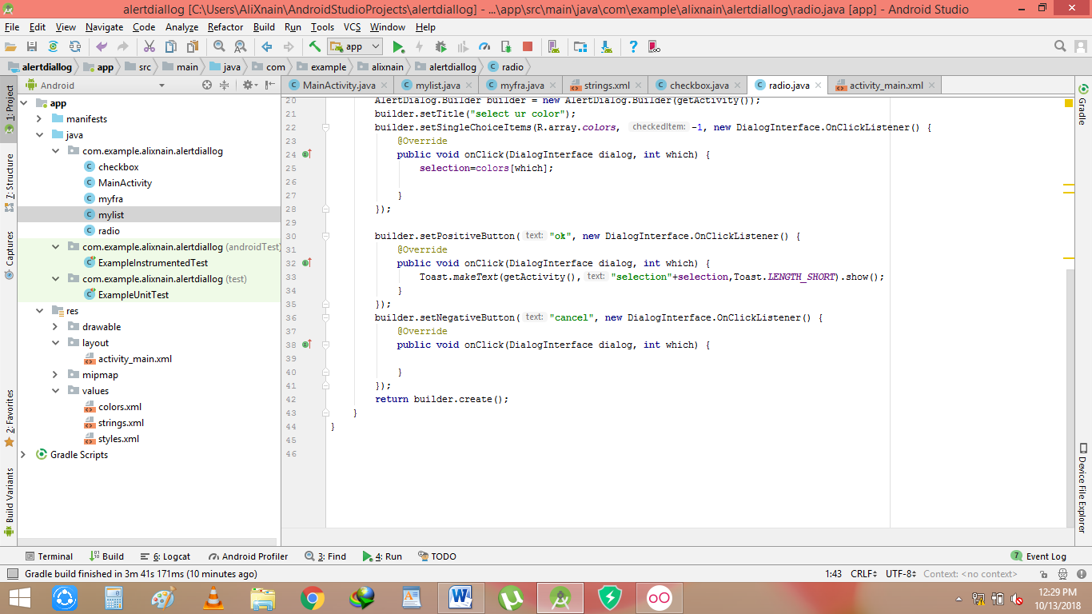

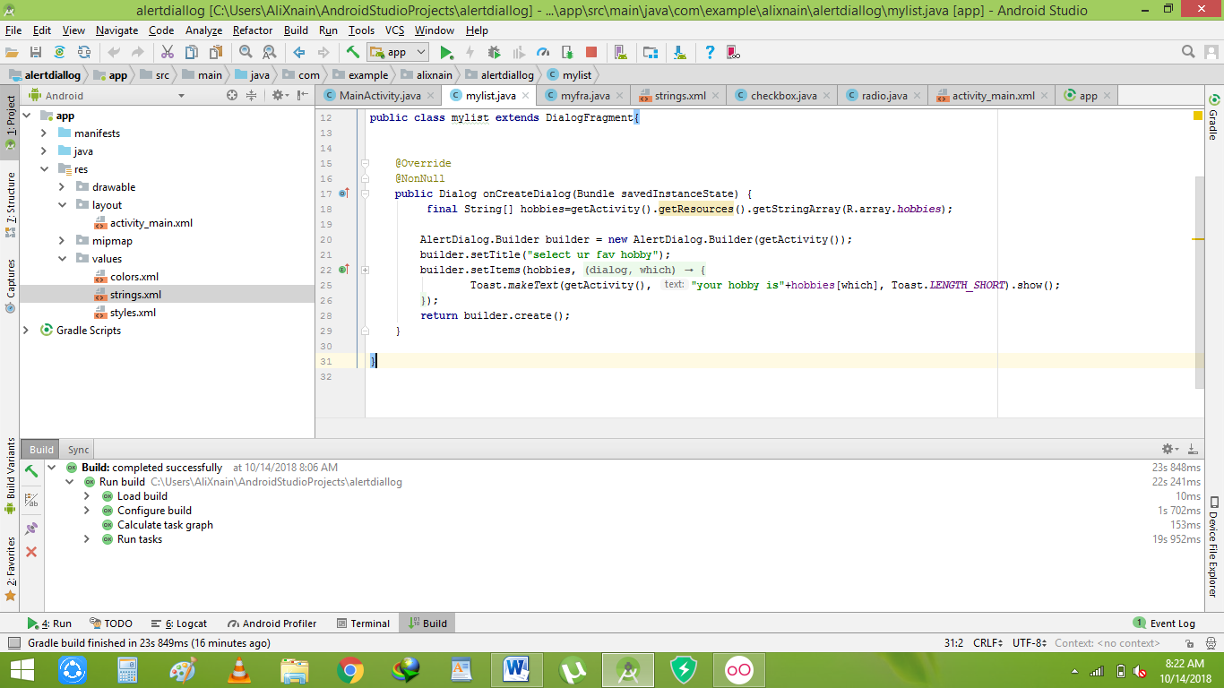

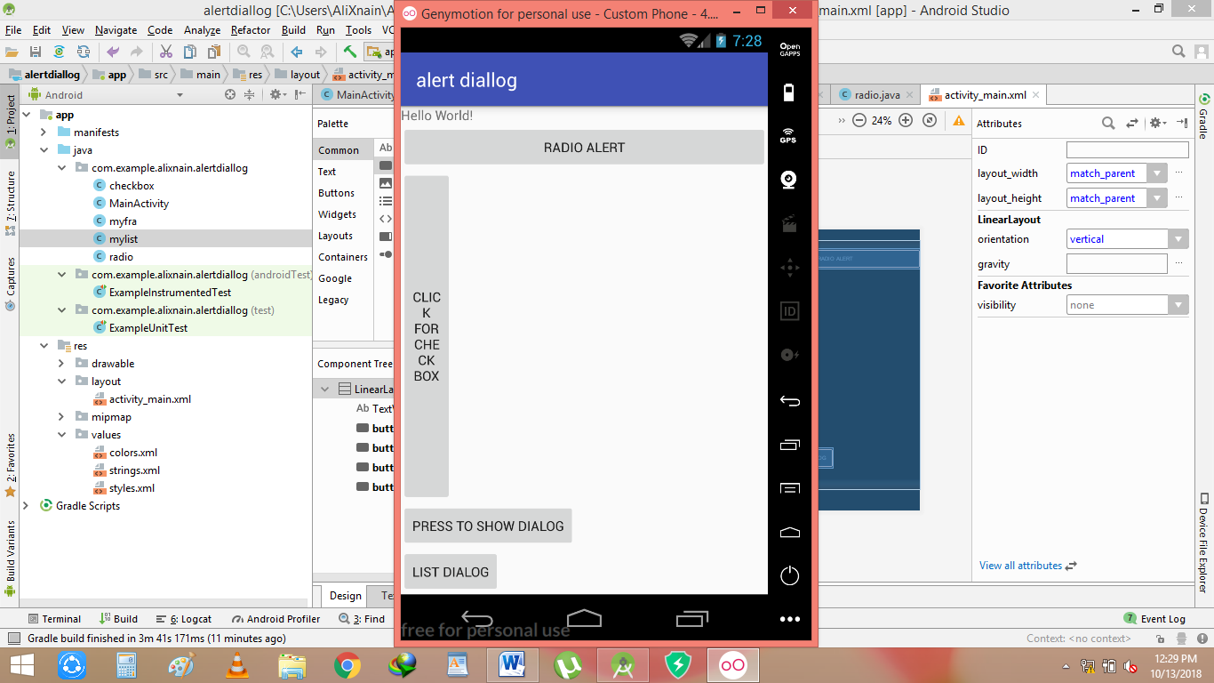

Customdialog:

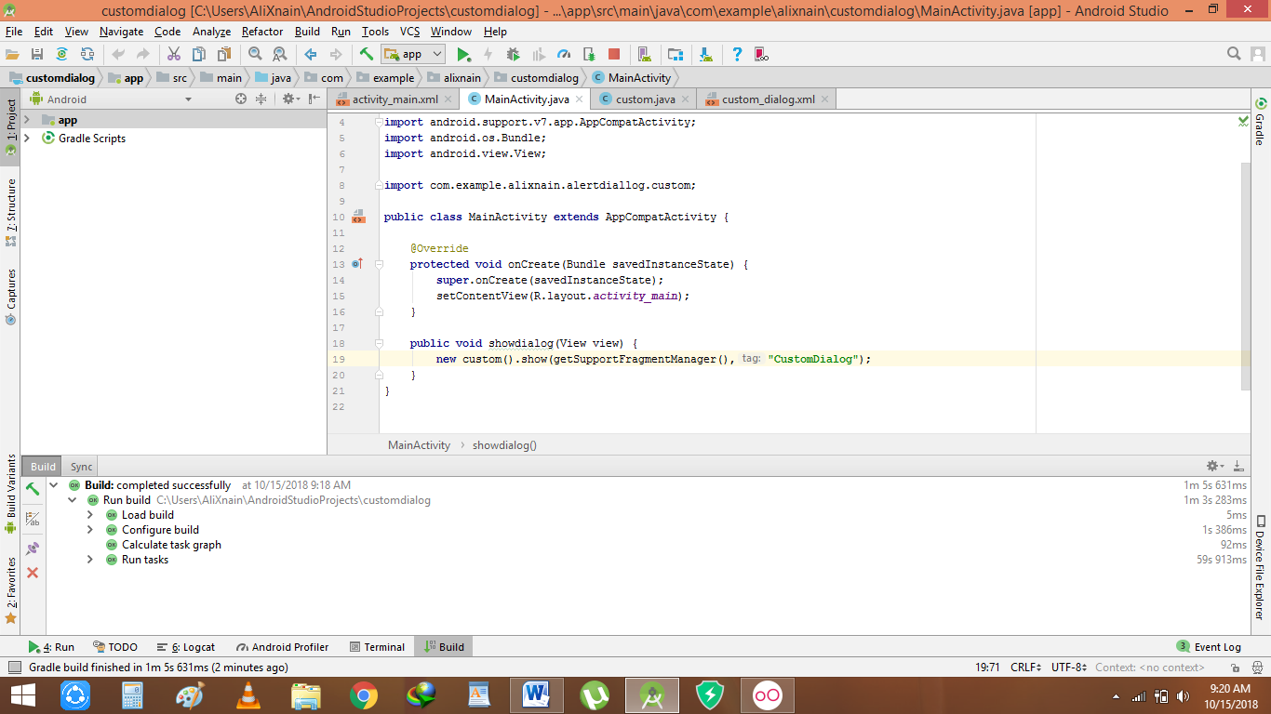

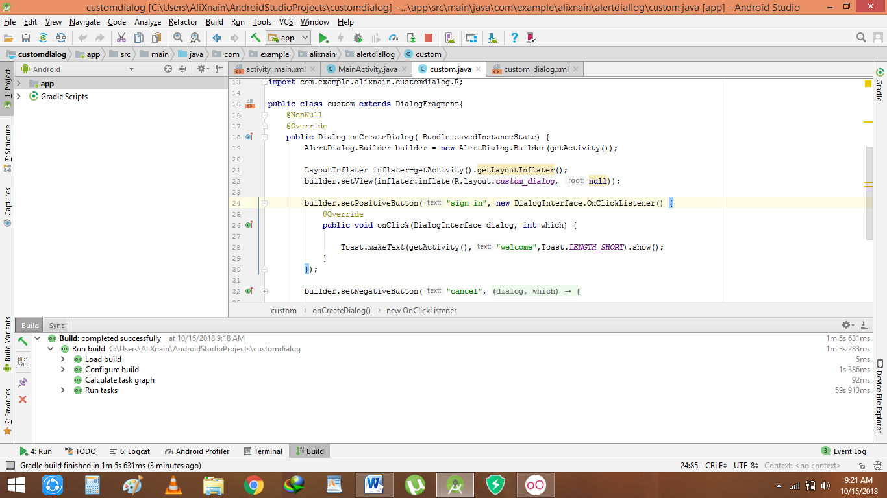

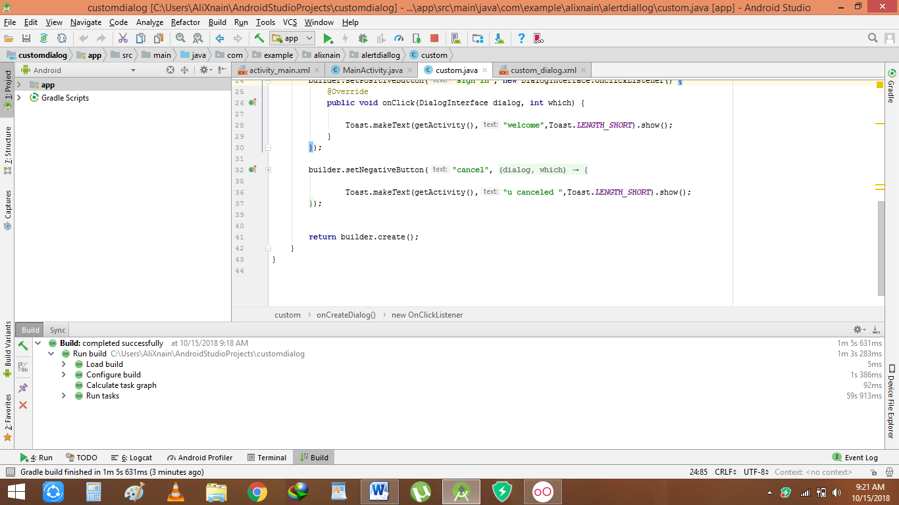

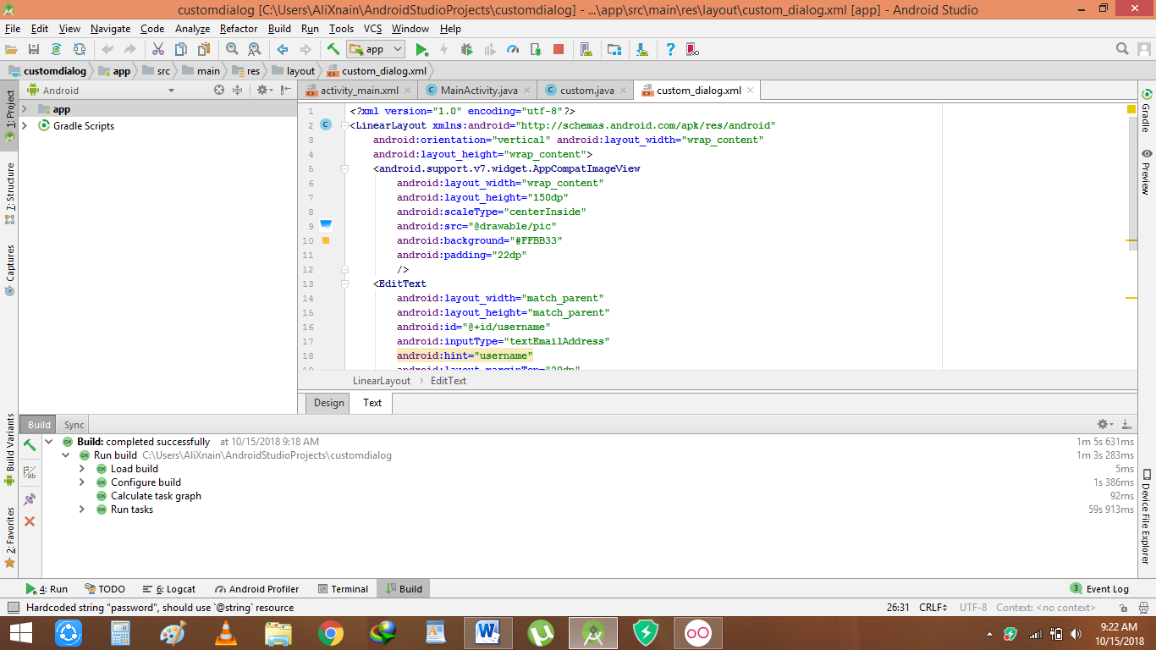

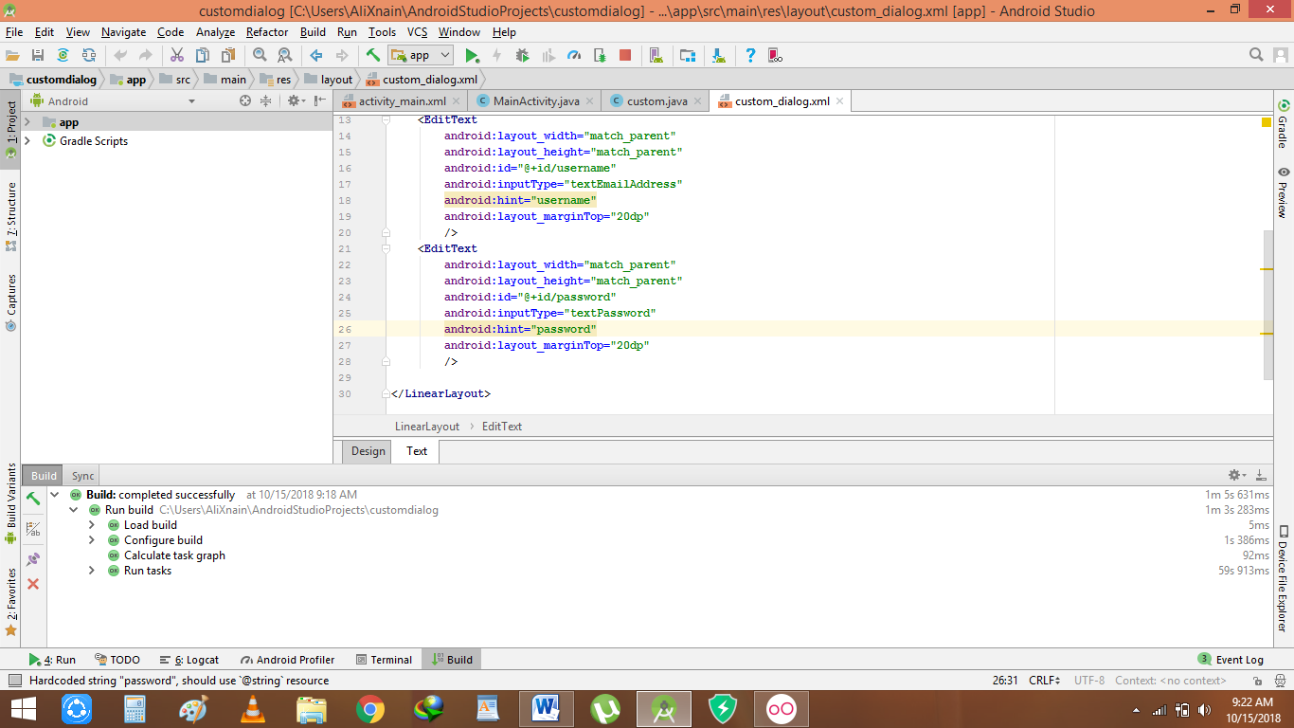

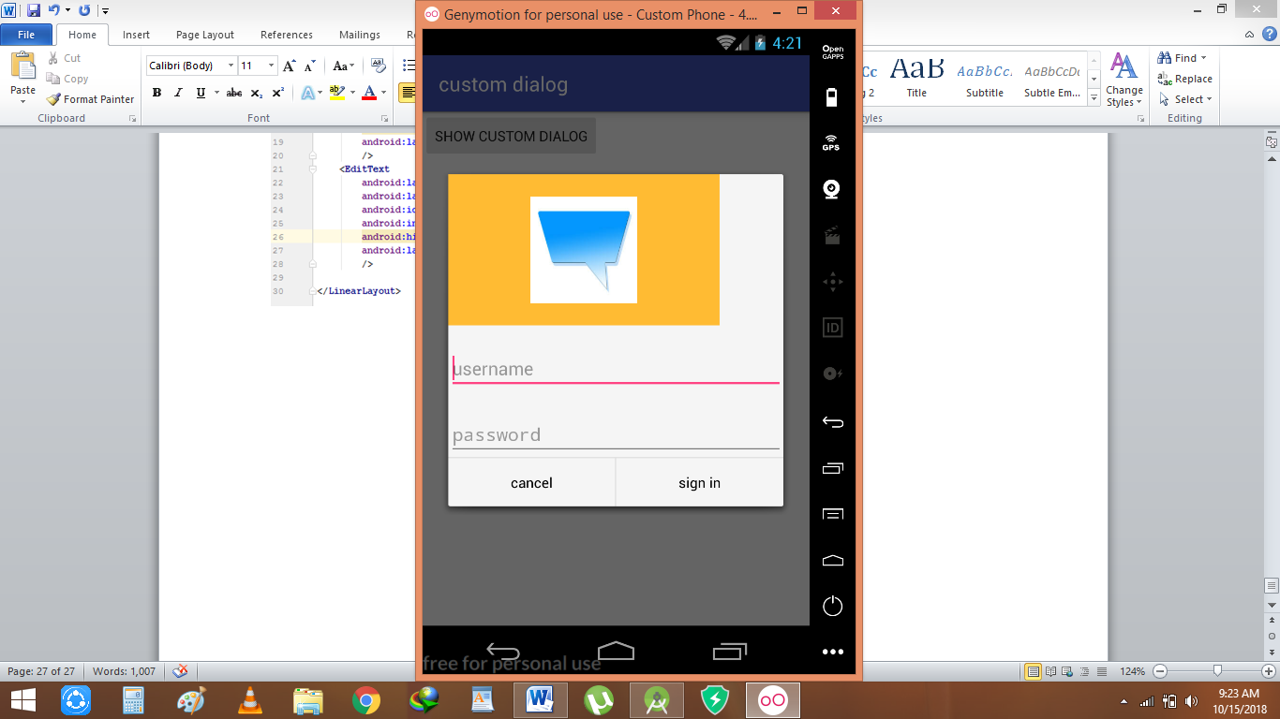

Rough:

**public void** playsound1(View view)  
 {  
**sp**.play(**s1**,1.0f,1.0f,0,0,10f);  
 }  
 **public void** playsound2(View view)  
 {  
 **sp**.play(**s2**,1.0f,1.0f,0,0,10f);  
 }  
 **public void** playsound3(View view)  
 {  
 **sp**.play(**s3**,1.0f,1.0f,0,0,10f);  
 }  
 **public void** playsound4(View view)  
 {  
 **sp**.play(**s4**,1.0f,1.0f,0,0,10f);  
 }  
 **public void** playsound5(View view)  
 {  
 **sp**.play(**s5**,1.0f,1.0f,0,0,10f);  
 }  
 **public void** playsound6(View view)  
 {  
 **sp**.play(**s6**,1.0f,1.0f,0,0,10f);  
 }  
 **public void** playsound7(View view)  
 {  
 **sp**.play(**s7**,1.0f,1.0f,0,0,10f);  
 }  
 **public void** playsound8(View view)  
 {  
 **sp**.play(**s8**,1.0f,1.0f,0,0,10f);  
 }  
 **public void** playsound9(View view)  
 {  
 **sp**.play(**s9**,1.0f,1.0f,0,0,10f);  
 }

gradle.projectsEvaluated {  
 tasks.withType(JavaCompile)  
 {  
 options.compilerArgs<<**"-Xlint:deprecation"** }  
}